----- 2 line Space (Times New Roman 16 pt. Bold) -----

Insert Title here (Style: Times New Roman, 16 pt. Bold)

----- 2 line Space (Times New Roman 16 pt. Bold) -----

ABSTRACT: (Times New Roman 12 pt. Bold, Upper Case)

Guidelines for preparation of the English Abstract for the 3nd International Conference on: New Technologies in Oil, Gas and Petrochemical Industries are presented. To save time and effort, please prepare your papers according to this guide.
In addition, each article must contain a Persian abstract on a separate page at the end of the article and in the format specified. (Style: Times New Roman, 11pt, Italic)
----- 1 line Space (Times New Roman 11 pt.) -----
Keywords: word, word, (Style: Times New Roman, 11pt. Italic)

1. Introduction (Times New Roman 12 pt. Bold)
It is important that the file be saved in the native format of the wordprocessor (Microsoft word)used. The text should be in single-column format in A4 paper. Keep the layout of the text as simple as possible.State the objectives of the work and provide an adequate background, avoiding a detailed literature survey or a summary of the results. Figures and tables should be embedded in the text (Times New Roman 11 pt.)

1.1 Subtitle 1 (Style: Times New Roman, 11pt, Bold)
Figures explanations should be under it (Times New Roman 10 pt. Bold)

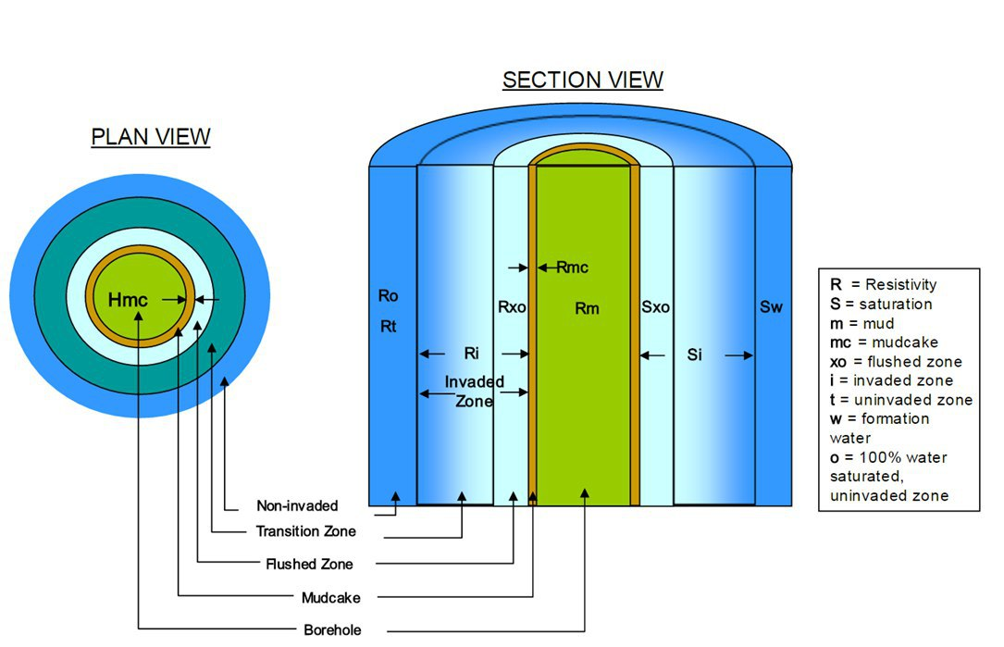
Fig 1- The sample is Figure (Style: Times New Roman, 10pt, Bold)

Fig 2- The sample is Chart (Style: Times New Roman, 10pt, Bold)

2.1 Subtitle 1 (Style: Times New Roman, 11pt, Bold)
Tables explanations should be above it (Times New Roman 10 pt. Bold)

Table 1. The sample is Table (Style: Times New Roman, 10pt, Bold)
a) Chemical composition of AA6351 alloy (% weight)
Si | Fe | Cu | Mn | Mg | Zn | Al
1.03 | 0.237 | 0.0723 | 0.584 | 0.665 | 0.003 | Balance

b) Mechanical properties of AA6351 alloy
Density  (x1000 kg/m³) | Elastic modulus  GPa | Tensile Strength  MPa | Elongation  % | Hardness  BHN
2.7 | 75 | 250 | 20 | 102

2. Experimental
Provide sufficient detail to allow the work to be reproduced. Methods already published should be indicated by a reference: only relevant modifications should be described. (Times New Roman 11 pt.)
3. Results and Discussion
Results should be clear and concise. This should explore the significance of the results of the work, not repeat them. A combined Results and discussion section is often appropriate. Avoid extensive citations and discussion of published literature. (Times New Roman 11 pt.)
4. Conclusions
The main conclusions of the study may be presented in a short Conclusions section, which may stand alone or form a subsection of a Discussion or Results and discussion section. (Times New Roman 11 pt.)

Acknowledgements
Collate acknowledgements in a separate section at the end of the article before the references and do not, therefore, include them on the title page, as a footnote to the title or otherwise. (Times New Roman 11 pt.)

References:
The reference list should be in alphabetical order

Citation in text
Please ensure that every reference cited in the text is also present in the reference list (and vice versa). Any references cited in the abstract must be given in full. Unpublished results and personal communications are not recommended in the reference list, but may be mentioned in the text. If these references are included in the reference list they should follow the standard reference style of the journal and should include a substitution of the publication date with either 'Unpublished results' or 'Personal communication'. Citation of a reference as 'in press' implies that the item has been accepted for publication.

Reference links
Use of the DOI is highly encouraged. A DOI is guaranteed never to change, so you can use it as a permanent link to any electronic article. An example of a citation using DOI for an article not yet in an issue is: Van Decar J.C., Russo R.M., James D.E., Ambeh W.B., Franke M. (2003). Aseismic continuation of the Lesser Antilles slab beneath northeastern Venezuela. Journal of Geophysical Research, https://doi.org/10.1029/2001JB000884. Please note the format of such citations should be in the same style as all other references in the paper.

Web references
As a minimum, the full URL should be given and the date when the reference was last accessed. Any further information, if known (DOI, author names, dates, reference to a source publication, etc.), should also be given. Web references can be listed separately (e.g., after the reference list) under a different heading if desired, or can be included in the reference list.

Reference style Text:
All citations in the text should refer to:
- Single author: the author's name (without initials, unless there is ambiguity) and the year of publication;
- Two authors: both authors' names and the year of publication;
- Three or more authors: first author's name followed by 'et al.' and the year of publication.
Citations may be made directly (or parenthetically). Groups of references can be listed either first alphabetically, then chronologically, or vice versa. Examples: 'as demonstrated (Allan, 2000a, 2000b, 1999; Allan and Jones, 1999)…. Or, as demonstrated (Jones, 1999; Allan, 2000)… Kramer et al. (2010) have recently shown …'

Reference List:
References should be arranged first alphabetically and then further sorted chronologically if necessary. More than one reference from the same author(s) in the same year must be identified by the letters 'a', 'b', 'c', etc., placed after the year of publication.
Examples:
Reference to a journal publication: Van der Geer, J., Hanraads, J.A.J., Lupton, R.A., 2010. The art of writing a scientific article. J. Sci. Commun. 163, 51–59. https://doi.org/10.1016/j.Sc.2010.00372.
Reference to a journal publication with an article number: Van der Geer, J., Hanraads, J.A.J., Lupton, R.A., 2018. The art of writing a scientific article. Heliyon. 19, e00205. https://doi.org/10.1016/j.heliyon.2018.e00205.
Reference to a book: Strunk Jr., W., White, E.B., 2000. The Elements of Style, fourth ed. Longman, New York.
Reference to a chapter in an edited book: Mettam, G.R., Adams, L.B., 2009. How to prepare an electronic version of your article, in: Jones, B.S., Smith, R.Z. (Eds.), Introduction to the Electronic Age. E-Publishing Inc., New York, pp. 281–304.
Reference to a website: Cancer Research UK, 1975. Cancer statistics reports for the UK. http://www.cancerresearchuk.org/ aboutcancer/statistics/cancerstatsreport/ (accessed 13 March 2003).

----- 2 سطر فاصله (قلم بی‌نازنین ۱۶، ضخیم، وسط‌چین) -----
عنوان مقاله حد‌اکثر ۲۰ کلمه و در 1 يا ۲ خط، (قلم بی‌نازنین ۱۶، ضخیم، وسط‌چین)
----- 1 سطر فاصله (قلم بی‌نازنین ۱۶، ضخیم، وسط‌چین) -----

چکیده: (قلم بی‌نازنین ۱۲، ضخیم)

در متن چكيده از ذكر مقدمات و كليات خودداري شود و مستقيماً به مسئله مورد مطالعه و اهداف آن، اساس كار، و ميزان موفقيت اين مطالعه با استناد به نتايج كار به طور مختصر اشاره شود. چكيده مقاله با (قلم بی‌نازنین، اندازه pt.12، نازک) با يک خط فاصله (single space)، ۲۵ میلیمتری فاصله از سمت راست و ۲۵ میلیمتری از سمت چپ كاغذ، با كناره‌هاي رديف شده نوشته شود. طول چكيده در مقاله كامل كمتر از ۸۰ كلمه و بيشتر از ۲۰۰ كلمه نباشد. چكيده بايد به تنهايي كامل و فقط داراي يك پاراگراف باشد. از اشاره به مراجع در چكيده خودداري شود. ضمناً مقالات به زبان انگلیسی بايد حاوي چکيده فارسی در يک صفحه مجزا در انتهاي مقاله و مطابق فرمت تعيين شده باشد.
----- ۱سطر فاصله (قلم بی‌نازنین ۱۲ و نازک) -----
واژه‌های کلیدی: حداکثر ۷ واژه که با ويرگول (،) از هم جدا شده و در يك خط باشند (قلم بی‌نازنین، اندازه pt.12 و نازک)

